**SYSTEM DESIGN**

**4.1 Introduction**

Here is the ILibrary system design, in this document will give the website and mobile application design.

**4.2 System Design (Description of the proposed system)**

Below we demonstrate a broad design of the system of how it communicated with each clients

1. **Client**: the client represents a mobile application and web browser. It made a connection to the server
2. **Web server:** Is the software hosting our system, and processes incoming networks request over http protocol
3. **MVC Controller:** This the entry point of system which is responsible of processing request coming from a browser, it process the request and return the html to the browser
4. **API:** This the entry point of the system which is responsible of processing request coming from the mobile, it process the request and return the data as JSON.
5. **Database:** This the system data source, its contains all data required to run the system.

**Database**

**API**

**MVC Controller**

**Web Server**

**Client**

**4.3 Architectural design**

**User Function Interface**

**Presentation layer**

**Information Service Sub system**

**Emergency Response sub system**

**Business layer**

System Maintenance

Information Management

Flood Simulation

Model Parameter Setting

**Services**

**Model service**

**Service layer**

Library staff service

User service

Books service

Library service

Library staff model

User model

Books model

Library model

**Data access layer**

**Data Access layer**

**Data Layer**

**4.4 Physical design**

**1. Library registration**

Does library ID exist

Enter library information

**NO** **YES**

Create the library

Display the error message

**2. Adding staff of library**

Create user account

Display message that email is taken

Does the provided email already exist?

Enter user information

NO YES

**3. Adding a book**

Save the book

Enter book information

**4. Register new user**

Save user account

Enter information

**4.5 Database design**

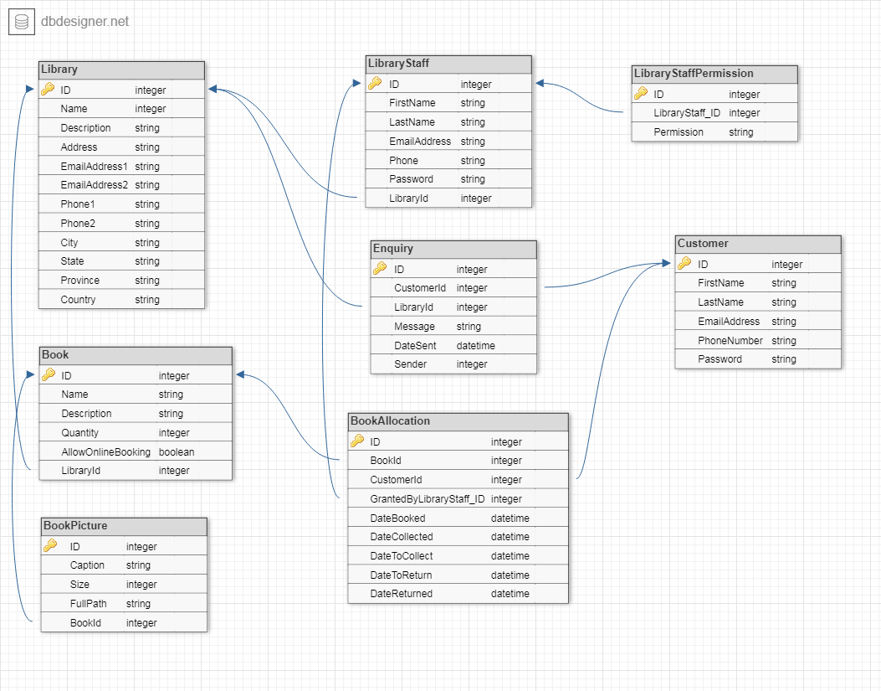

**4.6 Program design (Pseudo code)**

**1. Register library**

Get Library information

If library.Unique.ID exist, then

ReturnErrror (“This library unique ID is already taken”)

Else

Save (library)

End IF

**2. Add new book**

Get book information

If user is authenticated, then

Save (book)

Else

Return Error (“You must login first”)

End if

**3. Add new library staff**

Get staff information

If user is authenticated, then

If staff. Email is used then

Return Error (“This email address is already taken”)

Else

Save (staff)

End If

Else

Return Error (“You must login first”)

End if

**4. Library staff login**

Get username and password

If username does not exist, then

Return Error (“The username is not valid”)

Else

If password is valid then

Create Session ()

Else

Return Error (“Invalid password”)

End If

End if

**5. Create user account**

Get User information

Validate (information)

If user. Email exist, then

ReturnErrror (“This email address is already used by another user”)

Else

Save (library)

End IF

**6. User authentication**

Get email and password

If email does not exist, then

Return Error (“This email address does not valid”)

Else

If password is valid then

Create Session ()

Else

Return Error (“Invalid password”)

End If

End if

**4.7 Interface Design**

**Menu Interface**

**The website navigation menu**

**C:\Schools\ThridYearProject\Cloud based library\Captu564564re.PNG**

**The mobile app navigation menu**

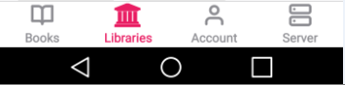

**Input Design**

**Form to add new library staff (website)**

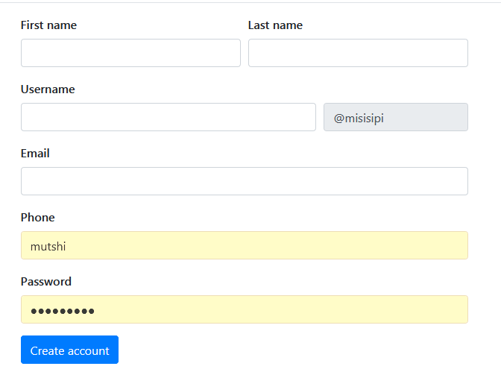

**Form to register a new library**

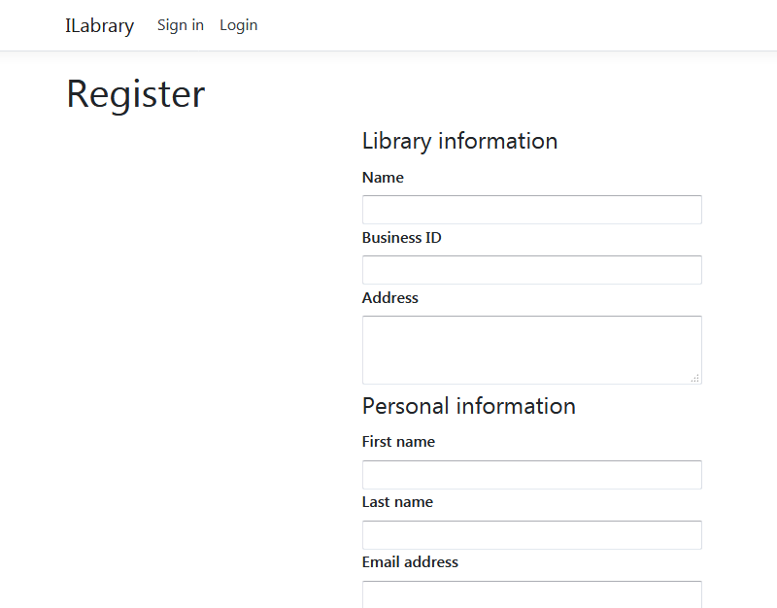

**Form to add a new book**

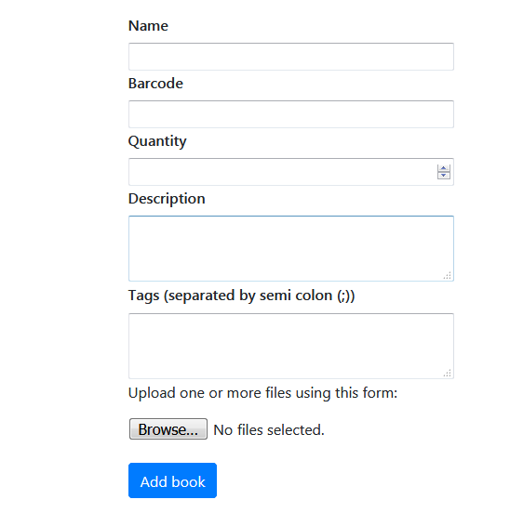

**Output design**

**List of books from the website**

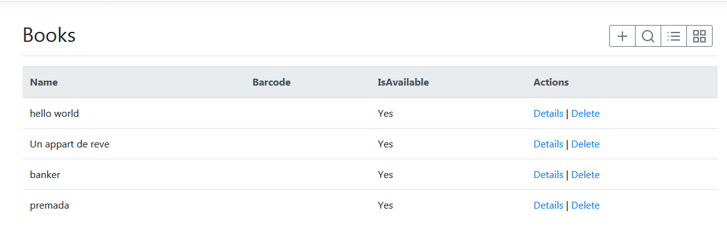

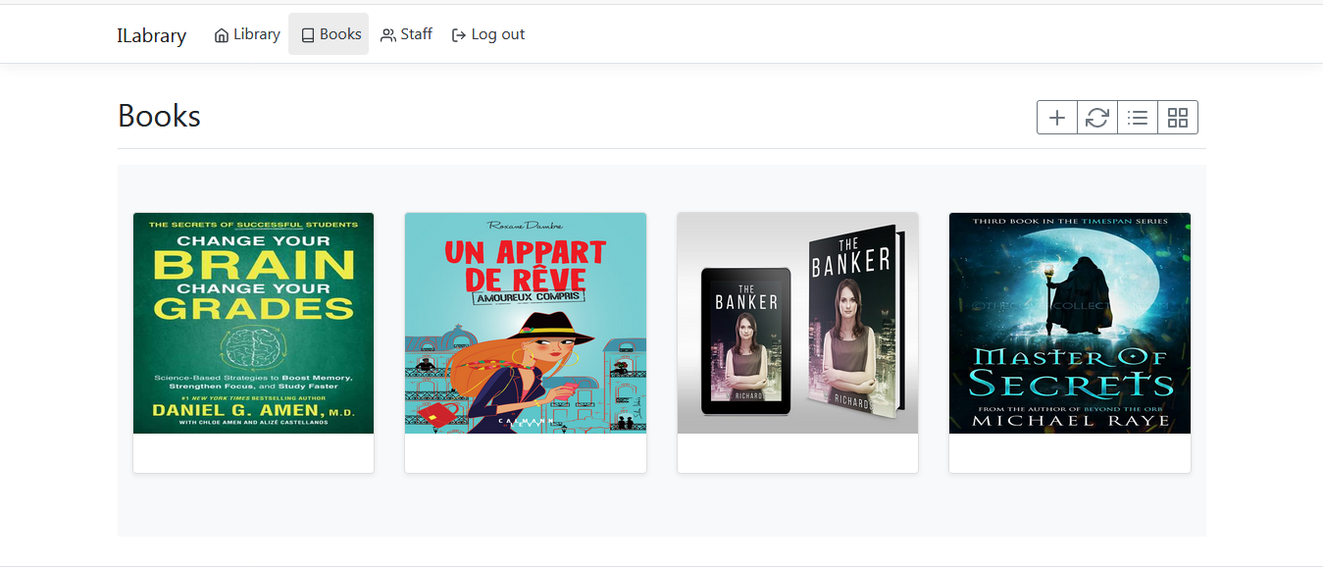

**List of books on the mobile app**

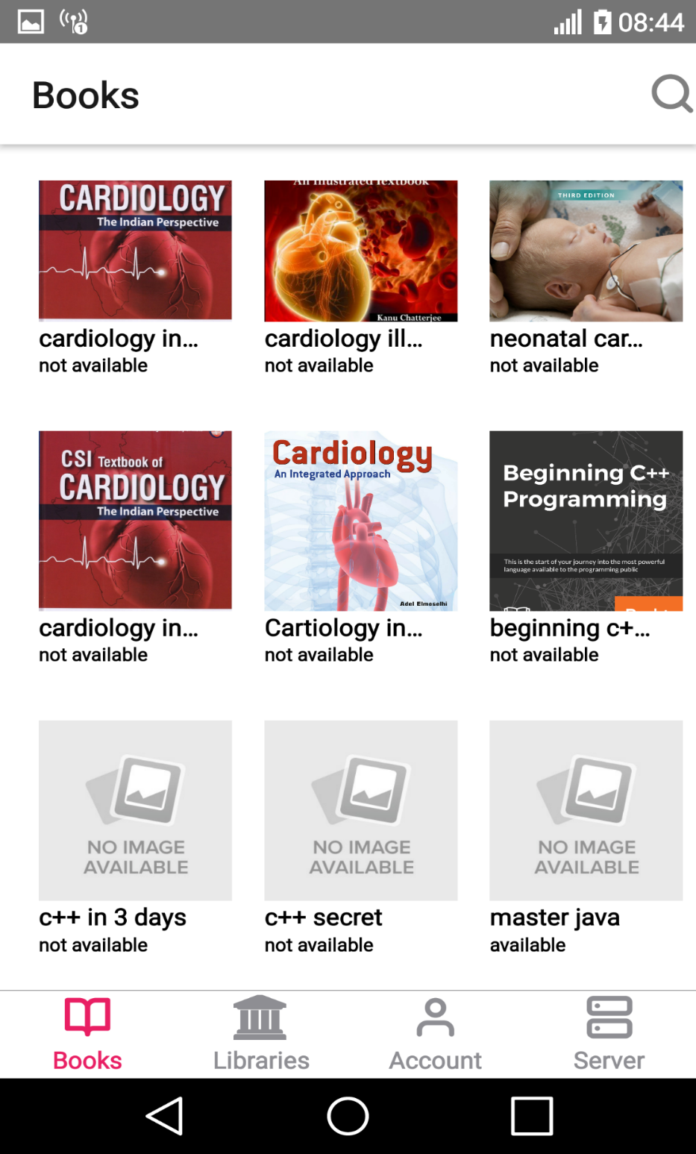

**List of libraries from the mobile app**

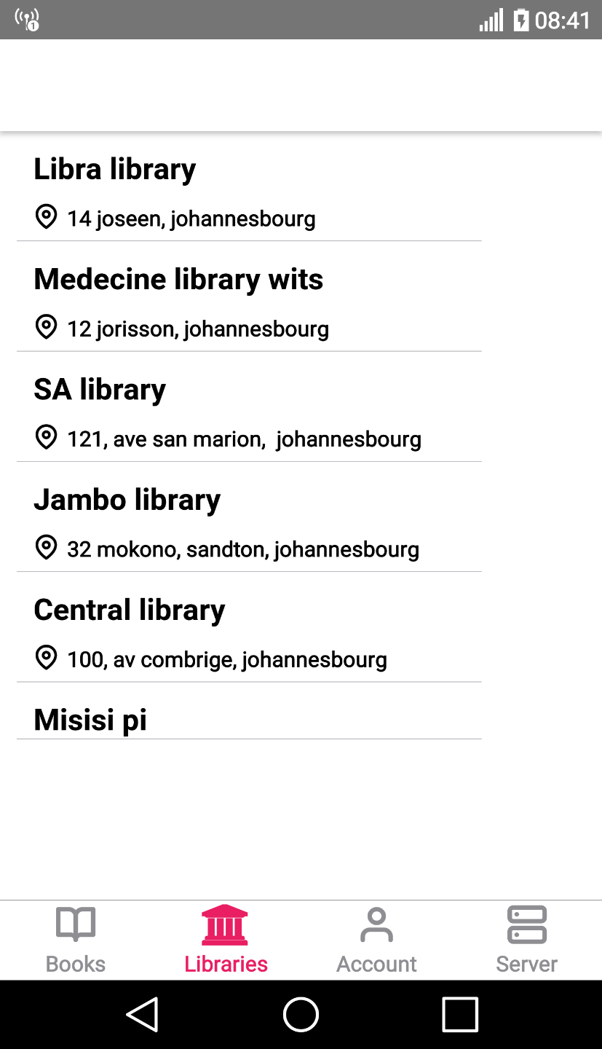

**A book detail,**

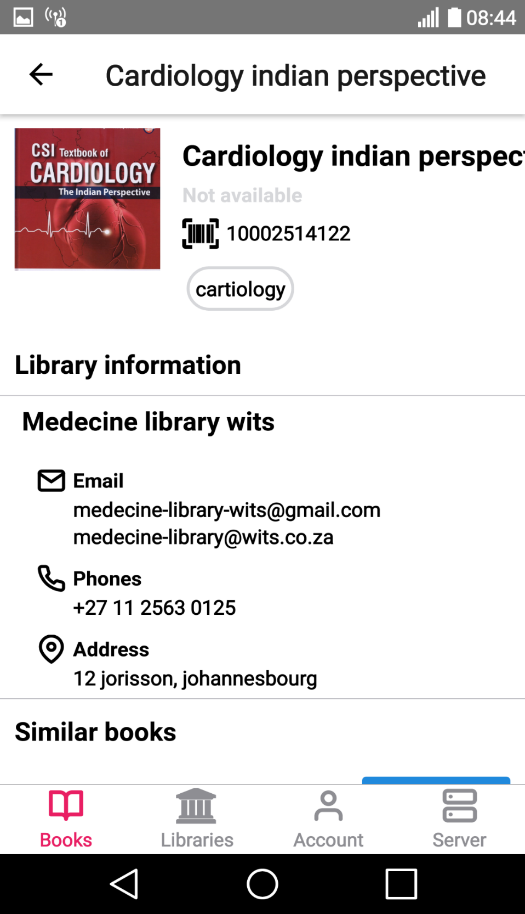

**A book detail with other similar books**

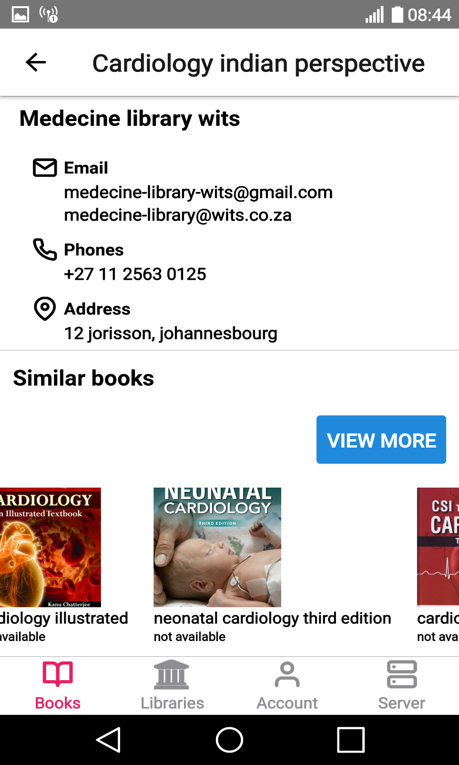

**4.8 Security back up design**

All the system data are saved in a SQLite database, as an SQLite database is simply a file it will simply backup on a different server (machine).

The backup can be made each and every day by simply copying the data base file to another sever.